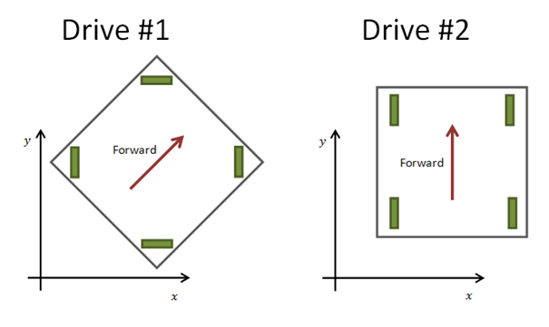 VEX X-Drive Programming

Video and Site

<http://blog.elliotjb.com/>

<https://www.youtube.com/watch?v=1-Ju_VqYLAU>

 Lets assume that you use one joystick to drive your robot, where Forward/Backward direction is mapped to Y and Left/Right - to X, and you already figured out how to use X and Y to control X Drive motors in robot-centric frame.

To get to the field-centric frame, first, you need to convert X and Y inputs into power magnitude P = sqrt(XX+YY) and angle theta = atan2(y,x).

Then you add (or subtract) your Gyro reading from theta and convert the power levels into robot-centric X2 and Y2 using Pcos(theta2) and Psin(theta2).

If you just doing it to learn how this works, the above code should be enough, however, if you need to depend on this to play 2v2 games, you will need to add a lot of the code to ensure that you handle Gyro drift and could reset it (using line trackers when crossing white lines) after the error gets too large.

Drift error will grow gradually with time or jump suddenly after robot collides with a wall or another robot.

I wouldn’t recommend field-centric driving controls for a season with heavy defense and frequent robot-to-robot interactions.

When we were using holonomic drive in Skyrise we put the strips of the colored tape on sides of the robot to help drivers orient themselves in robot-centric frame and it worked well…

X-Drive Program

#pragma config(Motor, port2, frontRight, tmotorNormal, openLoop)

#pragma config(Motor, port3, backRight, tmotorNormal, openLoop)

#pragma config(Motor, port4, frontLeft, tmotorNormal, openLoop, reversed)

#pragma config(Motor, port5, backLeft, tmotorNormal, openLoop, reversed)

//\*!!Code automatically generated by 'ROBOTC' configuration wizard !!\*//

/\*+++++++++++++++++++++++++++++++++++++++++++++| Notes |++++++++++++++++++++++++++++++++++++++++++++++

Mecanum Drive - Basic

- This program allows you to remotely control a robot with mecanum wheels.

- The left joystick Y-axis controls the robot's forward and backward movement.

- The left joystick X-axis controls the robot's left and right movement.

- The right joystick X-axis controls the robot's rotation.

[I/O Port] [Name] [Type] [Description]

Motor Port 2 frontRight VEX Motor Front Right motor

Motor Port 3 backRight VEX Motor Back Right motor

Motor Port 4 frontLeft VEX Motor Front Left motor

Motor Port 5 backLeft VEX Motor Back Left motor

----------------------------------------------------------------------------------------------------\*/

task main()

{

//Loop Forever

while(1 == 1)

{

//Remote Control Commands

motor[frontRight] = vexRT[Ch3] - vexRT[Ch1] - vexRT[Ch4];

motor[backRight] = vexRT[Ch3] - vexRT[Ch1] + vexRT[Ch4];

motor[frontLeft] = vexRT[Ch3] + vexRT[Ch1] + vexRT[Ch4];

motor[backLeft] = vexRT[Ch3] + vexRT[Ch1] - vexRT[Ch4];

}

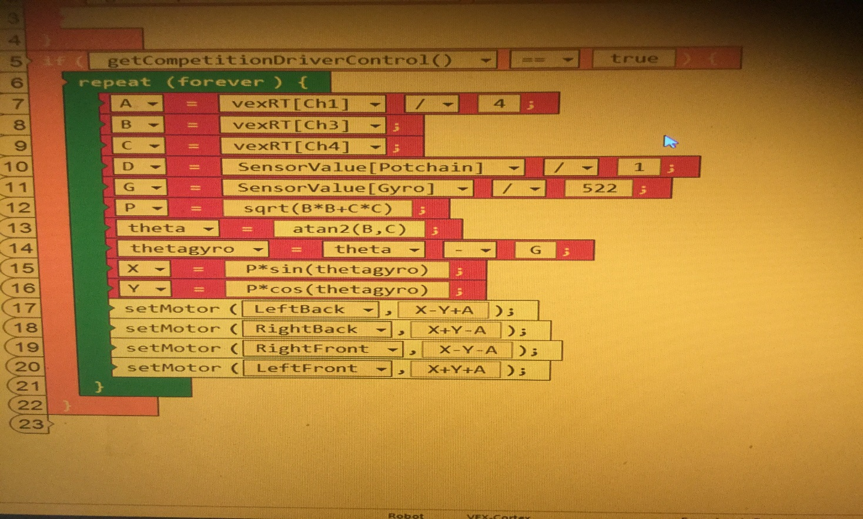}

-To move forward,

-To move backwards,

-To move sideways,

-To move diagonally,

-To turn Left,

-To turn Right,

